

**EXECUTIVE SUMMARY**

**FULLY AUTOMATED HYDROPONIC SYSTEM FOR SMALL SCALE PRODUCTION**

**BY:**

**PRIYANKA K**

**ROJIN RAJU**

**SRI SAKTICHARAN N**

**UMESH HARIHARA SUDAN M**

**PROJECT GUIDED BY:**

**Mr.T.THOMAS LEONID**

**Assistant Professor**

**FULLY AUTOMATED HYDROPONIC SYSTEM FOR SMALL SCALE PRODUCTION**

**PROBLEM STATEMENT:**



**With the advent of civilization soil-based agriculture is facing major challenges most importantly decrease in land availability. Poor** **soil fertility due to continuous cultivation and increased level of fertilizer application. Climate change and population increase are some major threats to the community.Unpredictability of Climate has caused a rise of 1 degree in earths Temperature.Continued changes in the frequency and intensity of precipitation, heat waves, and other extreme events are likely, all which will impact agricultural production. Furthermore, compounded climate factors can decrease plant productivity, resulting in price increases for many important agricultural crops. Global food production patterns would be fundamentally altered by climate change, causing food insecurity, Increase in demand for food because of small shifts in seasonality and water availability.Under such circumstances, in near future it will become impossible to feed the entire population using open field system of agricultural production only.**

**OBJECTIVES:**

* **To be used by the common people of the society.**
* **To meet the increading demands with population growth.**
* **To produce better yield even at severe climatic changes.**
* **To produce off season crops.**
* **To improve plant productivity and performance by using Advanced technology in lighting, nutrient delivery, and environmental control.**
* **No chemical weed or pest control products are needed.**
* **To increase shelf life by storing in controlled atmosphere.**
* **To reduce transport cost and increase profit margins.**
* **To resolve the problems that will be faced by us in future.**

**C:\Users\ADMIN\Desktop\pk project\targ.jpgTARGET COMMUNITY:**

**TARGETED GROUPS ARE:-**

* **Small scale farmers**
* **Organic farmers**
* **Super Markets**
* **Retailers**
* **Micro and Small Industries**
* **Common people who can grow in their house**

**NOVELTY:**

**Our Project aims to develop this project in a very minimalistic way so that**

* **Everyone can operate it easily .**
* **Cost Efficient and easily available.**
* **Easy to setup.**

**We provide Controlled environment for the Plants to grow Using IOT .**

**Sterilizing the Water and using it again by adding required nutrients again automatically.**

**Target audience in not MNC’s or Multi million dollar companies but Micro small and medium Industries.**

**Moreover compared to Other similar product by MNC’s our Product is cheap and affordable.**

**Our product also provide atmosphere controlled Storage facility.**

**Can produce any types of crops year-round.**

* **TECHNICAL IMPLEMENTATION:**
* **ASSEMBLE THE HYDROPONIC SYSTEM.**
* **MOINTORING OF CONSTANT TEMPERATURE,IRRIGATION,LIGHT CONTROL,NUTRIENT LEVEL AND YIELD.**
* **SELECT THE TYPE OF CROP.**
* **KEEP THE SEEDS IN THE ARRAY OF GROWING TUBES UNTIL FIRST LEAVES SHOW UP.**
* **MIX THE REQUIRED NUTRIENTS WITH WATER TO MAKE HYDROPONIC SOLUTION.**
* **TURN ON THE MOTOR AND PUMPS DAILY.**
* **ATMOSPHERIC TEMPERATURE IS CONTROLLED USING TEMPERATURE VALVES**
* **INSPECT FOR PESTS AND DISEASES.**
* **EVERY PARAMETER CAN BE VIEWED VIA WEBSITE.**
* **CONSTANT UPDATES ARE PROVIDED.**
* **CROPS ARE HARVESTED AND STORED IN CONTROLLED ENVIRONMENT TO INCREASE SHELF LIFE.**

**BLOCK DIAGRAM:**

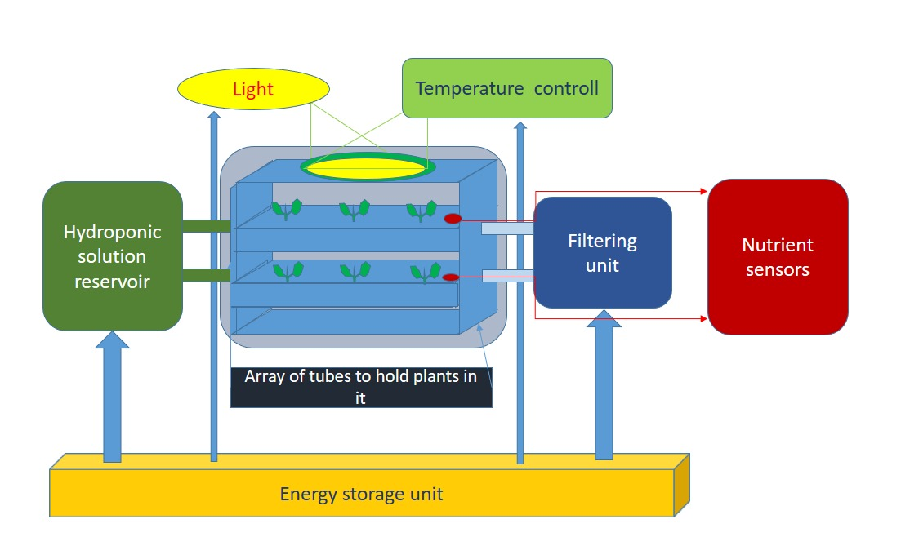

**C:\Users\ADMIN\Desktop\pk project\adva.pngOUTCOMES:**

* **Used 20 times less water than the soil based farming.**
* **Up to 90% more efficient use of water.**
* **Fourfold harvest yield was achieved.**
* **Production increased in the same amount of space.**
* **No chemical weed is needed.**
* **Less work because it is fully automated.**